**Task 1**

.386

.model flat,stdcall

.stack 4096

ExitProcess proto,dwExitCode:dword

.data

var1 db 10

var2 db 20

.code

main PROC

; Move the values into the registers

mov al, var1 ; al has 10, ah has garbage value

mov bl, var2 ; bl has 20, bh has garbage value

add al, bl ; al would have 30, ah would have garbage value

INVOKE ExitProcess,0

main ENDP

END main

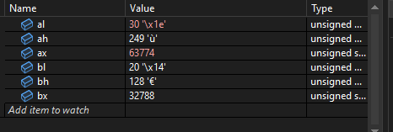

**Task 2**

.386

.model flat,stdcall

.stack 4096

ExitProcess proto,dwExitCode:dword

.data

var1 db 10

var2 db 20

.code

main PROC

; Move the values into the registers

mov al, var1 ; al has 10, ah has garbage value

mov bl, var2 ; bl has 20, bh has garbage value

sub bl, al ; bl would have 10, ah would have garbage value

INVOKE ExitProcess,0

main ENDP

END main

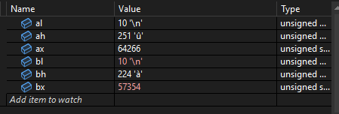

**Task 3**

.386

.model flat,stdcall

.stack 4096

ExitProcess proto,dwExitCode:dword

.data

var1 db 10

var2 db 30

.code

main PROC

; Move the values into the registers

mov al, var1 ; al has 10, ah has garbage value

mov bl, var2 ; bl has 30, bh has garbage value

mul bl ; ax would be 300, al would be 44 and ah would be 1

INVOKE ExitProcess,0

main ENDP

END main

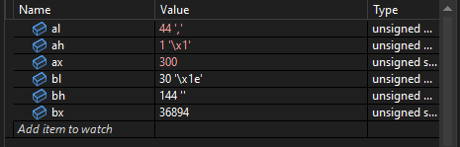

**Task 4**

.386

.model flat,stdcall

.stack 4096

ExitProcess proto,dwExitCode:dword

.data

var1 db 10

var2 db 3

.code

main PROC

; Move the values into the registers

mov ax, 10 ; al has 10, ah has 0

mov bl, var2 ; bl has 3, bh has garbage value

div bl ; ah would be 1, al would be 3

INVOKE ExitProcess,0

main ENDP

END main

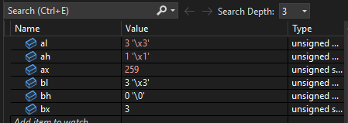

**Task 6**

.386

.model flat,stdcall

.stack 4096

ExitProcess proto,dwExitCode:dword

.data

coal db 3

data_structure db 4

linear_algebra db 4

Marketing db 4

Discrete db 3

data_lab db 4

coal_lab db 3

credithrstheory db 3

credithrslab db 1

.code

main PROC

; Move the values into the registers

mov al, coal; al has 3

mov bl, credithrstheory; bl has 3, bh has 0

mul bl; al is 9, ah is 0

mov coal, al

mov al, data_structure; al has 4

mul bl; al is 12, ah is 0

mov data_structure, al

mov al, linear_algebra ; al has 4

mul bl; al is 12, ah is 0

mov linear_algebra, al

mov al, Marketing; al has 4

mul bl; al is 12, ah is 0

mov Marketing, al

mov al, Discrete; al has 3

mul bl; al is 9, ah is 0

mov Discrete, al

mov al, data_lab; al has 4

mov bl, credithrslab; bl has 1, bh has 0

mul bl; al is 4, ah is 0

mov data_lab, al

mov al, coal_lab; al has 3

mul bl; al is 3, ah is 0

mov coal_lab, al

INVOKE ExitProcess,0

main ENDP

END main

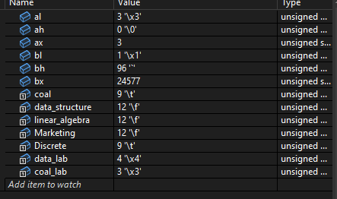

**Task 7**

.386

.model flat,stdcall

.stack 4096

ExitProcess proto,dwExitCode:dword

.data

coal db 3

data_structure db 4

linear_algebra db 4

Marketing db 4

Discrete db 3

data_lab db 4

coal_lab db 3

credithrstheory db 3

credithrslab db 1

sum_credits db 0

.code

main PROC

; Move the values into the registers

mov al, coal; al has 3

mov bl, credithrstheory; bl has 3, bh has 0

mul bl; al is 9, ah is 0

mov coal, al

mov al, data_structure; al has 4

mul bl; al is 12, ah is 0

mov data_structure, al

mov al, linear_algebra ; al has 4

mul bl; al is 12, ah is 0

mov linear_algebra, al

mov al, Marketing; al has 4

mul bl; al is 12, ah is 0

mov Marketing, al

mov al, Discrete; al has 3

mul bl; al is 9, ah is 0

mov Discrete, al

mov al, data_lab; al has 4

mov bl, credithrslab; bl has 1, bh has 0

mul bl; al is 4, ah is 0

mov data_lab, al

mov al, coal_lab; al has 3

mul bl; al is 3, ah is 0

mov coal_lab, al

mov al, sum_credits; al has 0, ah has 0

mov bl, coal; bl has 9

add al ,bl; al has 9

mov bl, data_structure; bl has 12

add al, bl; al has 21

mov bl, linear_algebra; bl has 12

add al, bl; al has 33

mov bl, Marketing; bl has 12

add al, bl; al has 45

mov bl, Discrete; bl has 9

add al, bl' al has 54

mov bl, data_lab; bl has 4

add al, bl; al has 58

mov bl, coal_lab; bl has 3

add al, bl; al has 61

mov sum_credits, al; sum_credits has 61

INVOKE ExitProcess,0

main ENDP

END main

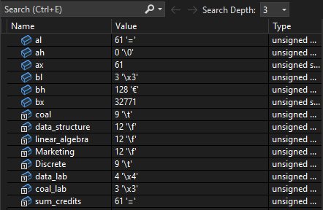

**Task 8**

.386

.model flat,stdcall

.stack 4096

ExitProcess proto,dwExitCode:dword

.data

coal db 3

data_structure db 4

linear_algebra db 4

Marketing db 4

Discrete db 3

data_lab db 4

coal_lab db 3

credithrstheory db 3

credithrslab db 1

sum_credits db 0

total_credits db 17

gpa_whole db 0

gpa_point db 0

.code

main PROC

; Move the values into the registers

mov al, coal; al has 3

mov bl, credithrstheory; bl has 3, bh has 0

mul bl; al is 9, ah is 0

mov coal, al

mov al, data_structure; al has 4

mul bl; al is 12, ah is 0

mov data_structure, al

mov al, linear_algebra ; al has 4

mul bl; al is 12, ah is 0

mov linear_algebra, al

mov al, Marketing; al has 4

mul bl; al is 12, ah is 0

mov Marketing, al

mov al, Discrete; al has 3

mul bl; al is 9, ah is 0

mov Discrete, al

mov al, data_lab; al has 4

mov bl, credithrslab; bl has 1, bh has 0

mul bl; al is 4, ah is 0

mov data_lab, al

mov al, coal_lab; al has 3

mul bl; al is 3, ah is 0

mov coal_lab, al

mov al, sum_credits; al has 0, ah has 0

mov bl, coal; bl has 9

add al ,bl; al has 9

mov bl, data_structure; bl has 12

add al, bl; al has 21

mov bl, linear_algebra; bl has 12

add al, bl; al has 33

mov bl, Marketing; bl has 12

add al, bl; al has 45

mov bl, Discrete; bl has 9

add al, bl; al has 54

mov bl, data_lab; bl has 4

add al, bl; al has 58

mov bl, coal_lab; bl has 3

add al, bl; al has 61

mov sum_credits, al; sum_credits has 61

mov bl, total_credits; bl has 17

div bl; al has 3 ah has 10

mov gpa_whole, al; gpa_whole has 3

mov gpa_point, ah; gpa_point has 10

INVOKE ExitProcess,0

main ENDP

END main

